Introduction

* User interface introduction

1. main

1. OpenLocalProject

You can open one of all Provisioning.sln in {ProjectSourceFolder}\Provisioning.sln

Include set eWDK.

1. BulidLocalProject

You can rebuild all(x86&x64 | x86&arm64) and create local package one of all Provisioning.sln in {ProjectSourceFolder}\Provisioning.sln

1. UpdateExternalDrops

You can update external drops, rebuild all(x86&x64 | x86&arm64) and create local package one of all Provisioning.sln in {ProjectSourceFolder}\Provisioning.sln

If nuget spec version file mismatch, will delete the mismatch package folder to avoid get package failed.

1. GetRemoteProject

You can clone DeviceProvisioning repository, checked out selected remote product branch, and new local personal branch from production branch

The default local personal branch name is personal/{UserProfile}/{SelectedProject} and the local folder name is {SelectedProject}

If you input specific name in NewBranchName textbox, local personal branch name will be personal/{UserProfile}/{SelectedProject}_{specific} and the local folder name will be {SelectedProject}_{specific}

If you not selected Production Branch, will using the latest modified production branch.

Include init, updated external drops, rebuild all and create local package.

1. GetProvisioningArtifact

Please download AZ CLI before use this function

Download url: [Overview of the Azure CLI | Microsoft Docs](https://docs.microsoft.com/en-us/cli/azure/)

First time to use should login az

And then select a branch and click ok

1. InstallSurfacePackage

You can install new version capsule from nuget.

Support 3 formats and multi rows.

Install-Package Devices.Cardinal.Driver.SurfaceME.RS5.Test -version 11.8.70.3626

Install-SurfacePackage Devices.Cruz.Driver.SurfaceSAM.RSx.Test.RollBack -version 241.6.139.0 -Source Cruz

[f:Cruz][p:Devices.Cruz.Driver.SurfaceSAM.RSx.Test.RollBack][v:241.6.139.0][a:content\amd64\release\drv\SurfaceSAM.inf

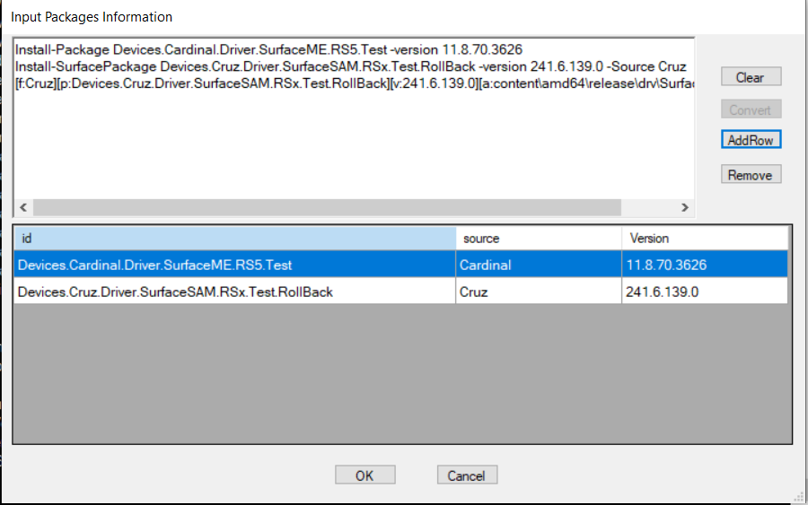

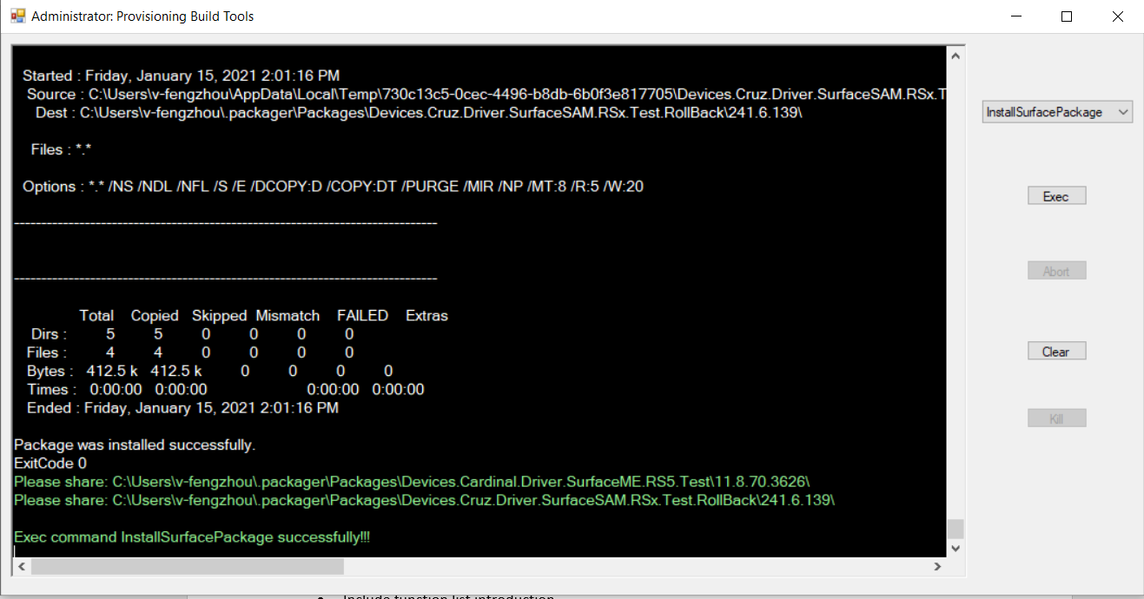

1. UploadNugetPackage

You can upload provisioningTools change in local ExternalDrops folder to nuget.

Include CreateHashAndVersion and overwrite new version in Packages.config.

1. CapsuleParser

Processing file in {CapsuleFolder} and update version in capsule Info configuration

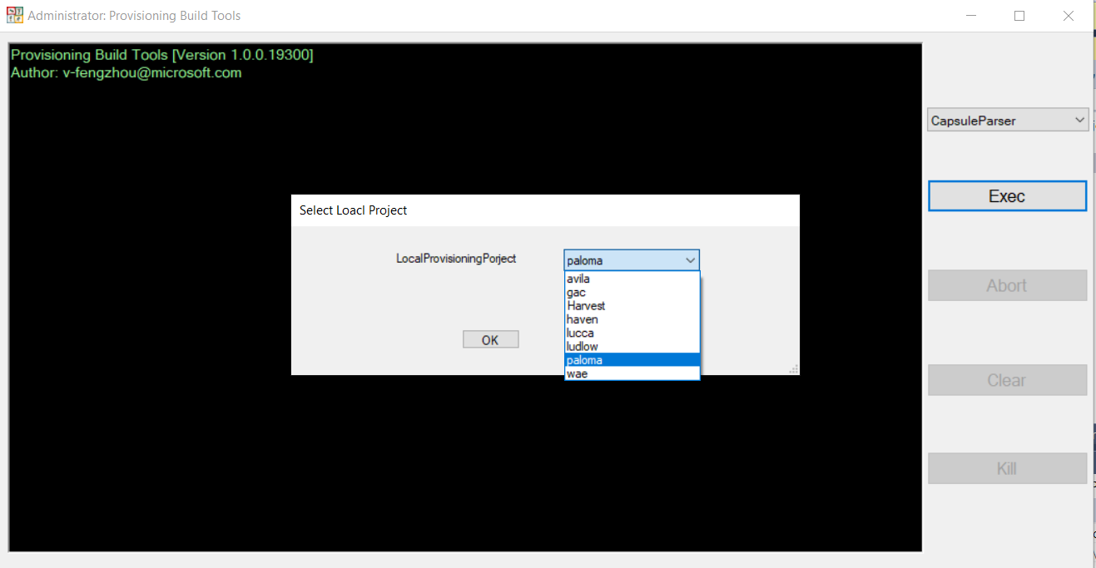

1. ProvisioningTester

Call ProvisioningTester.exe in provisioning package folder with selected input arguments

* Configuration introduction

1. defaultSourceFolder: the root path of all projects source
2. maxAvilableSlot: the max slot value for ProvisioningTester
3. you can specific config project setting for one project

* like command line

1. for example, just input ‘b’ and press {Enter} to BuildLocalProjet

1. use ‘help’ or ‘?’ to see all supported format

